PROBLEM SOLVING TESTING USING JAVA
TASKS

TASK 1

Salary Transformation

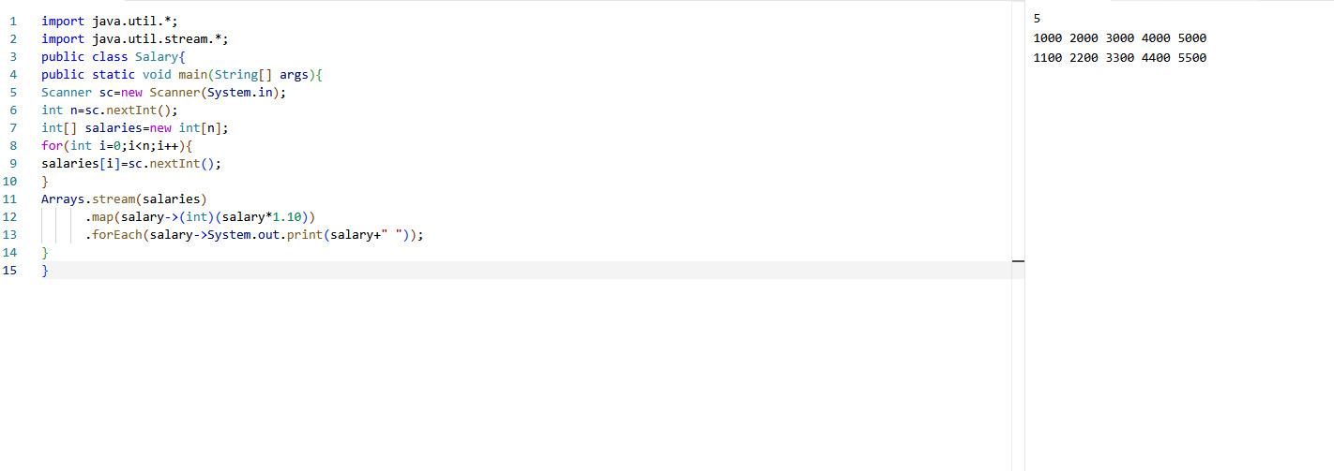

TASK 2

Real-Time Stream Analytics Engine

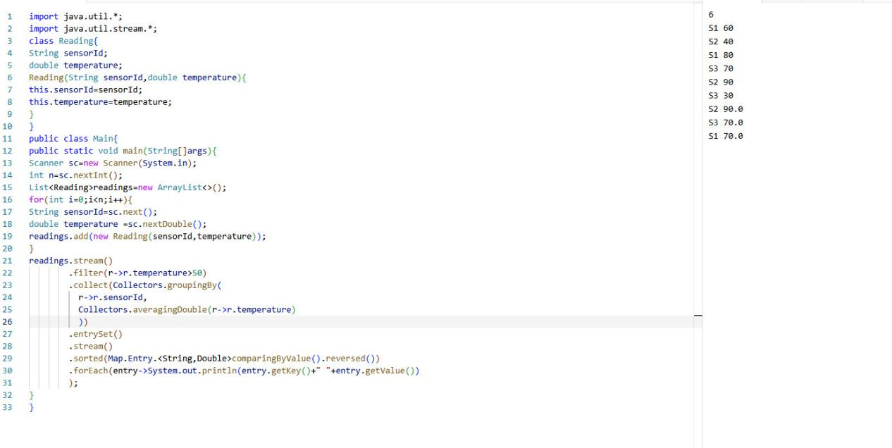

TASK 3

Maximum Profit Analyzer

